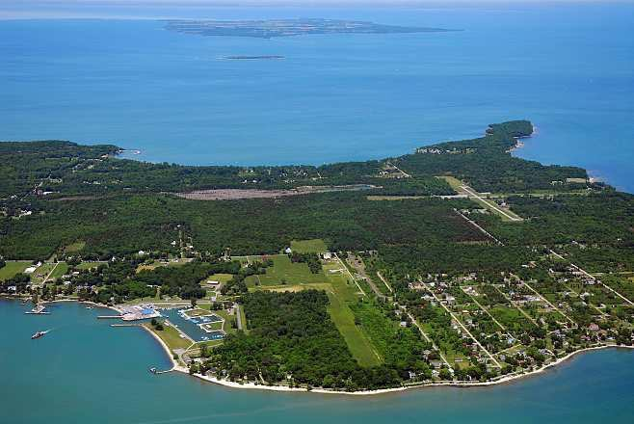
OHIO, KELLEYS ISLAND – RETAIL ASSOCIATE / SHOP KEEPER
Booga Shack is a company runs a couple gift shops. Company is located in a small island in Ohio, Great Lake Area. It is a perfect place for summer students. Swimming, canoeing, skiing, boat trips and tons of attraction and it is just 30 mins from mainland by ferry Ferry runs every 2 hr to Sandusky and another Ferry runs every ½ hour to smaller town in summer season. Employer is looking for retail sales / shop keeper associates. That is a great job to improve your English level when you are working in a very fun job.
You will be responsible all operations at the store and customers. Short stocking, consulting, selling, cleaning and money operations should be handled and of course we need huge smile as you can see on pics... (Students from past year)
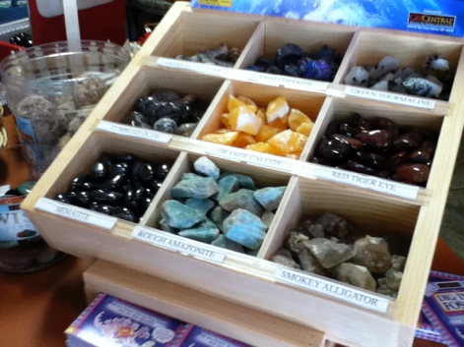
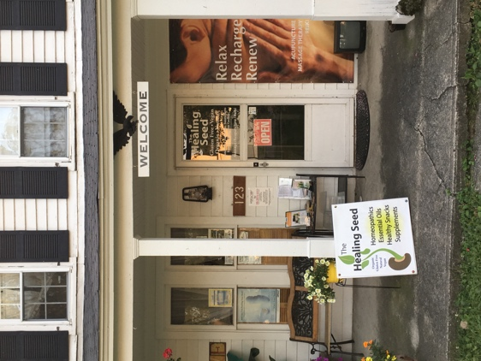
Pat Ahner dba Booga Shack
Island Mining Co., /The Little Healing Room
Kelleys Island, OH 43438 USA
ahnerpat@gmail.com
954-330-9425

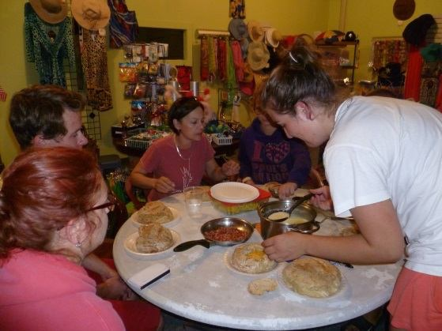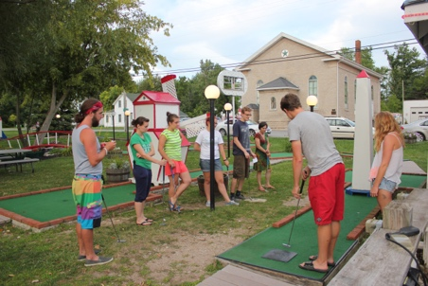
Salaries: 8.30 USD per hour (or current Ohio minimum wage) for Retail Sales Accommodation: 70 USD per week, if students stay through their agreed contract they will get a housing refund of 3.60 USD per day. That means if you complete your contract, you will pay 45 USD per week. Motivations: Island, sea, sun, fun, cultural mix and real American life. Special Rules: No abuse of electronics while working, no smoking, clean and neat appearance, to be fresh every single day and PERSONAL HYGIENE...
You will have wonderful summer in Ohio... send resume: ahnerpat@gmail.com

