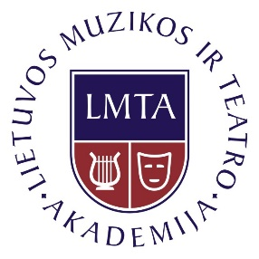 | Study Programme: | Music Performance
 | National Code: | 6121PX010
 | Specialisation: | Harpsichord
 | Cycle: | First (Bachelor)
 | Group of Study Fields: | Arts
 | Main Study Field: | Music
 | Study Volume: | 240 ECTS credits

Curriculum

No. | Subjects | Semesters | Assessment
 | Harpsichord | 1-7 | Exam
 | Secondary Instrument (Piano / Organ)* | 1-6 | Pass / Fail, Exam
 | Harpsichord Structure and Tuning | 2 | Exam
 | Chamber Ensemble | 1-7 | Pass / Fail, Exam
 | Basics of Basso Continuo | 3 | Exam
 | Figured Bass | 4 | Exam
 | Ear Training | 1-4 | Exam
 | Harmony | 5 | Exam
 | Polyphony | 6 | Exam
 | Basics of Musical Works Analysis | 7 | Exam
 | History of Harpsichord Art | 1-2 | Pass / Fail, Exam
 | Alternatives of Music History | 1-4 | Exam
 | History of Lithuanian Music and Culture | 5-6 | Pass / Fail, Exam
 | Professional Practice | 7-8 | Pass / Fail, Exam
 | Foreign Language | 1-2 | Pass / Fail, Exam
 | Philosophy | 1-2 | Exam
 | Basics of Aesthetics | 3 | Exam
 | Basics of Music Aesthetics | 4 | Exam
 | Language of the Profession | 7 | Pass / Fail
 | Optional Subjects | 1-8 | Exam
 | Chamber Ensemble Art Project | 8 | Defense
 | Final Art Projects | 8 | Defense
* Student every year should choose one of the secondary instrument alternative for one year.

