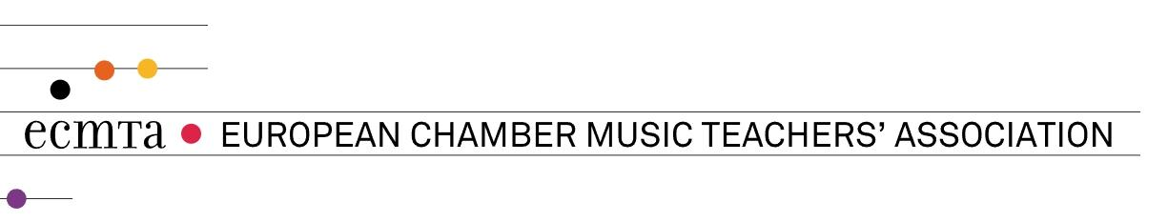
ECMTA SPRING MEETING IN VILNIUS (LMTA) - 21-23 April, 2023

LMTA Building I Gedimino av. 42, Vilnius
LMTA Building II Vilniaus 6-2, Vilnius

Friday, April 21
12:00–13:45  Building I, 2nd floor, entrance to the Karosas Hall | Registration
14:00  Building I,  the Karosas Hall | Opening of the Spring Meeting  assoc. prof. dr. Judita Žukienė - Rector of LMTA  prof. Rimantas Armonas – Head of Chamber Ensemble Department
14:15–15:00  Building I,  the Karosas Hall | Key LMTA Speaker: LMTA prof. Mindaugas Urbaitis  Classical music in contemporary chamber works of Lithuanian composers
15:30–16:30  Building II,  refer to the schedule on the 1st floor | Masterclasses
17:00–18:30  Building II,  refer to the schedule on the 1st floor | Masterclasses
19:00  Building I, 3rd floor,  the Great Hall | Concert at the LMTA  Students from Kaunas Juozas Naujalis Music Gymnasium, Tallinn School of Music and Ballet  and Estonian Academy of Music and Theatre
Saturday, April 22
10:00  Building II, room 227 | Key LMTA Speaker: Marta Finkelštein, doctoral student, Chamber ensemble department  Playing in contemporaneity. The curatorial approach to concert design
11:00  Building II, room 227 | Members’ Forum
13:30  Building II, room 227 | Key ECMTA Speaker: Gretchen Amussen  Understanding Power Relations and Hierarchies of Power. What might  this suggest for chamber musicians and for teaching chamber music?
14:30–16:00  Building II,  refer to the schedule on the 1st floor | Masterclasses
16:30–18:00  Building II,  refer to the schedule on the 1st floor | Masterclasses
19:00  Building I, 3rd floor,  the Great Hall | CONCERT DEDICATED TO THE LMTA’S 90TH ANNIVERSARY  Students from LMTA Chamber Ensemble Department
Sunday, April 23
10:00  Building II, room 227 | General Assembly
11:30  Building II,  refer to the schedule on the 1st floor | Masterclasses

Participants of the Spring Meeting in Vilnius, April 21-23 2023
1. Evan Rothstein, the Guildhall School of Music & Drama
2. Katarzyna Jankowska, Chopin Music University in Warsaw, Poland
3. Daiva Stulgytė-Povilaitienė, Kaunas Juozas Naujalis Music Gymnasium
4. Piotr Różański, Polish Chamber Musicians' Association, The Krzysztof Penderecki Academy of Music in Kraków
5. Eilis Cranitch, Associazione Ensemble Xenia
6. Pekka Helasvuo, JSW Jean Sibelius Works
7. Marje Lohuaru Chairwoman of the ECMTA
8. Tuomas Untamala Kuopio Conservatory
9. Piret Väinmaa, Tallinn College of Music and Ballet, Association “In Corpore”, Estonia
10. Natalia Sakkos Estonian Academy of Music- and Theatre, Tallinn College of Music and Ballet, Estonian Chamber Music Teachers Associaton
11. Anneli Tohver, Estonian Academy of Music and Theatre
12. Maila Laidna Secretary of the ECMTA
13. Petras Kunca, the Lithuanian Musician‘s Union
14. Katariina Liimatainen, Savonia University of Applied Sciences
15. Carlo Bertola, the Turin Conservatoire Giuseppe Verdi
16. Raimundas Simanavičius, Kaunas Juozas Naujalis Music Gymnasium
17. Karolina Beinarytė-Palekauskienė, Kaunas Juozas Naujalis Music Gymnasium
18. Gretchen Amussen, Key Speaker No 1
19. Joanna Maklakiewicz, Chopin Music University in Warsaw, Poland
20. Grzegorz Mania, Polish Chamber Musicians’Association, The Feliks Nowowiejski Academy of Music in Bydgoszcz
21. Jana Peäske, Association “In Corpore”, Estonia (staying only until Kaunas day)
22. Ewa Leszczyńska, Polish Chamber Musicians Association
23. Yiannis Miralis, European University Cyprus
24. Rimvydas Savickas; Lithuanian Musicians Union, Lithuanian Academy of Music and Theatre
25. Ilona Klusaite, Kaunas Juozas Naujalis Music Gymnasium
26. Jaan Kapp, Heino Eller Tartu Music College
27. Kadri Leivategija, Heino Eller Tartu Music College
28. Audronė Nekrošienė, Lithuanian Musicians’ Union
29. Emlyn Stam, New European Ensemble
30. Indrė Baikštytė, LMTA

