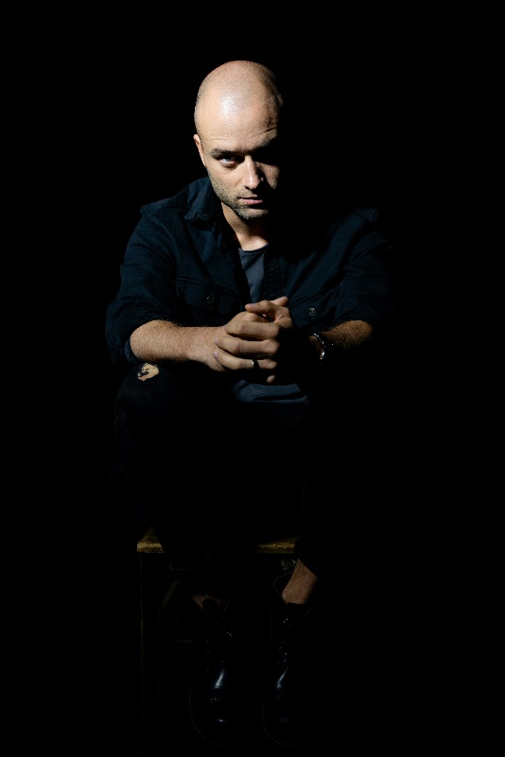
Aleksandras Špilevojus (b. 1987) is a director, playwright, actor and theatre teacher.
He studied music technology at Kaunas University of Technology, later completed bachelor’s and master’s studies in acting at the Lithuanian Academy of Music and Theatre, and is currently pursuing a doctorate in theatre directing.
Špilevojus has worked as an actor, playwright, and director at the Lithuanian National Drama Theatre, the Old Theatre of Vilnius, and the Menų Spaustuvė (Arts Printing House). Presently, he is the artistic director at the Juozas Miltinis Drama Theatre, and the head and founder of the theatre-laboratory called Meno Alchemija (The Alchemy of Art). He also acts and directs in Lithuanian theatres as well as film projects in various European countries.

In 2016, Špilevojus received recognition for his first play titled Neišmoktos Pamokos (Unlearnt Lessons), winning the Open Space competition at the Menų Spaustuvė, and being shortlisted for one of the most prestigious contemporary drama festivals, Lyubimovka (Moscow). He has also won the Dalia Tamulevičiūtė Lithuanian Drama Competition, and in 2017, his production based on the same play was nominated for the Golden Cross of the Stage Award in the Theatre+ category.
In 2018, Špilevojus received the Young Creator Award from the Lithuanian Ministry of Culture, and the Golden Stage Cross in 2019 for the dramaturgy of the play Bagadelnia, which he directed at Šiauliai Drama Theatre. In 2020, he directed the performance of the band The Roop, which won the Lithuanian Eurovision Song Contest national selection. In the same year, Špilevojus won the Best Director Award at the Dalia Tamulevičiūtė Theatre Festival for his production Irano Konferencija (The Iranian Conference, Ivan Vyrypaev), and was named Panevėžys Citizen of the Year for his contributions to theatre. In 2021, he was nominated for the Golden Stage Cross for the play Irano Konferencija, and won the Best Performance Award at the COM MEDIA International Theatre Festival for this work.

Playwriting portfolio

2023 Jona
2022 Sala, kurios nėra
2022 Pakeliui
2021 Stepai, gazo!
2021 Anti. Gone
2020 Žmogus iš KGB
2019 12 gramų į šiaurę
2018 Bagadelnia
2016 Babelis
2015 Neišmoktos pamokos

Productions directed

2023 Jona (Aleksandr Špilevoj), Juozas Miltinis Drama Theatre
2022 Sala, kurios nėra (Aleksandr Špilevoj), Juozas Miltinis Drama Theatre
2022 Pakeliui (Aleksandr Špilevoj), Šiauliai Drama Theatre
2022 Jaudulys / Excitement (Ivan Vyrypaev), Kaunas National Drama Theatre and Meno Alchemija
2022 Šv. Speigas (inspired by Quentin Tarantino’s The Hateful Eight), Juozas Miltinis Drama Theatre
2022 Pasitikėjimo žaidimas (Miglė Anušauskaitė), Lithuanian National Radion and Television
2021 Stepai, gazo! (Aleksandr Špilevoj), Meno Alchemija
2021 Anti (Aleksandr Špilevoj), Meno Alchemija and Panevėžys Menas Drama Theatre
2020 Irano konferencija / The Iranian Conference (Ivan Vyrypajev), Juozas Miltinis Drama Theatre
2019 12 gramų į šiaurę (Aleksandr Špilevoj), State Small Theatre of Vilnius
2018 Bagadelnia (Aleksandr Špilevoj), Šiauliai Drama Theatre
2018 Urodas/ The Ugly One (Marius von Mayenburg), The Old Theatre of Vilnius
2016 Neišmoktos pamokos (Aleksandr Špilevoj), Menų Spaustuvė

Key acting roles

2021 Narrator in A. Špilevojus’s Stepai, gazo!, dir. A. Špilevoj
2018. Jim Morrison, presenter in A. Špilevojus’s Bagadelnia, dir. A. Špilevoj
2018 DJ in M. von Mayenburg’s Urodas / The Ugly One, dir. A. Špilevoj
2016 Lead in A. Špilevojus’s Neišmoktos pamokos, dir. A. Špilevoj
2016 Judas Iscariot in A. Andreev Septyni fariziejaus Sauliaus penktadieniai / Seven Fridays of Saul the Pharisee, dir. J. Vaitkus
2016 Lead in Kodas: HAMLET (based W. Shakespeare’s play), dir. O. Lapina
2015 Dervish, Prisoner in Nizami Ganjavi’s Septynios gražuolės / The Seven Beauties, dir. J. Vaitkus
2014 Vadimas in P. Priazhko’s Puikus gyvenimas / Life is Grand, dir. T. Jašinskas
2014 Edgaras; Cornwall’s servant in W. Shakespeare’s Karalius Lyras / King Lear, dir. J. Vaitkus
2013 Andriušis in K. Binkis’s Atžalynas, dir. J. Vaitkus
2013 Moscow gentleman in A. Pushkin’s Eugenijus Oneginas / Eugene Onegin, dir. J. Vaitkus
2012 Soldier in A. Vvedensky’s Eglutė pas Ivanovus / Christmas Tree at the Ivanovs, dir. J. Vaitkus

Professional achievements and awards

2021 Award for the play Irano konferencija as best play at the COM MEDIA International Theatre Festival.
2021 Golden Stage Cross nomination for the acting team for the play Irano konferencija
2020 Panevėžys Citizen of the Year Award for contributions to art and education
2020 Best Director at the Dalia Tamulevičiūtė Theatre Festival for the play Irano konferencija (Ivan Vyrypayev).
2020 First place in the Eurovision Song Contest national selection as the director of the The Roop’s performance of the song On Fire
2019 Golden Stage Cross (National Drama category) for the play Bagadelnia.
2018 Young Creator Award, Ministry of Culture of the Republic of Lithuania
2017 Golden Stage Cross nomination in the category Theatre+ for the play Neišmoktos pamokos
2016 Main Award of the Dalia Tamulevičiūtė Lithuanian Drama Competition of the play Neišmoktos pamokos

A Performer’s Personal Stance and Will

One of the fundamental postulates of storytelling states:
- The storyteller is always the author of their own narrative;
- The storyteller must possess and convey a personal stance concerning the narrative and the actions of its characters.

Having a personal stance and a strong inner desire to convey the author’s story to the audience empowers the performer to harness their will, strength, resolve and determination. This significantly enhances the logical, emotional and auditory dimensions of the narrative. Hence, contemporary theatre educators and the most skilled professional actors frequently employ storytelling as an effective method to nurture artistic creativity and develop essential professional skills.

