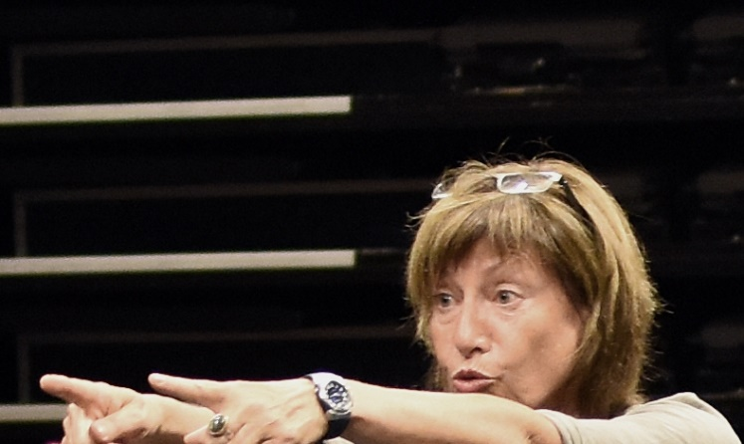
Viola Schmidt was born in Berlin in 1958. From 1978 to 1982, she studied Speech Science and German Language at the Faculty of Arts at the Martin Luther University Halle/Wittenberg in Germany and graduated with a Diploma. After two years of research, she received her doctorate in 1985. From 1984 to 2001, she worked as a voice and speech trainer at the University of Theatre Ernst Busch Berlin. From 2001 to 2003, she was Professor of Voice and Speech at the University of Music and Theatre Felix Mendelssohn Bartholdy Leipzig. In 2003, she returned to Berlin and since then has been Professor of Voice and Speech at the University of Theatre Ernst Busch Berlin and Head of the Voice and Speech Training Section in the Acting Department. From 2005 to 2011, she was Vice Rector of the University and developed the international collaborations. From 2017 to 2018 she was visiting professor at Nord Universitet Bodø in Norway. She has worked as a voice and speech trainer at various German theaters and has conducted workshops in Germany, Austria, Denmark, Iceland, UK, Russia and China.
Since 2016 she teaches within the Berlin Actor Training of NYU Tisch School of the Arts. Her textbook on the method of Gestus “Mit den Ohren sehen” was published in 2019.

Masterclass
The method of using Gestus in voice and speech training developed at the University of Theatre Ernst Busch Berlin.

Instructed by Viola Schmidt and Franziska Trauselt
November 6th 2023 180 minutes
12 participants, as much observers as possible
Instructions in English

Starting from the increasingly cognitive usage of spoken language nowadays, the method of Gestus conveys speaking as part of a purposeful mode of behavior, which requires participation of the whole body.
It is based on motivated and intended behavior on stage. We speak to enter into relationships and try to change the behavior of others.
The method was developed from the concept of Gestus described by Bertolt Brecht and has since been continuously expanded and updated.
The training starts by investigating your own material (body, breath, voice, speech). You learn to find your own stability through using gravity and centering in the relationship to various partners while communicating.
You discover the space inside just as the space around and learn to address expression. It is provided to have an impression before an expression. The voice extends the physical expression into defined spaces.
You understand speaking as part of your behavior, as part of aimed acts with a clear physical and vocal, a visible and audible Gestus.
You learn to use the physical tension of your body for sounding personally and intentionally.
The voice is made permeable for concrete physical states of tension. The body thus remains flexible in the interchange of tensing and releasing, of giving and taking.
All exercises are partner-related and take place in game situations. The exercises train the ability to perceive and react quickly and directly as well as to use voice under physical strain without losing the Gestus.
According to the method of Gestus the training imparts speaking as articulated thinking. The need for mental exchange creates articulation as an instrument that can mediate between people.
Spoken text is embodied as a dialog that creates different situations.
The principles of communication and their relationship to presentation on stage are investigated. Reflections on the relationship between perception and behavior provide information about the human image that underlies the method.
The method uses our ability to cooperate. Our need to share ideas with other people is at the heart of this methodical approach.
There is a principle of hope that people care for each other while communicating.

