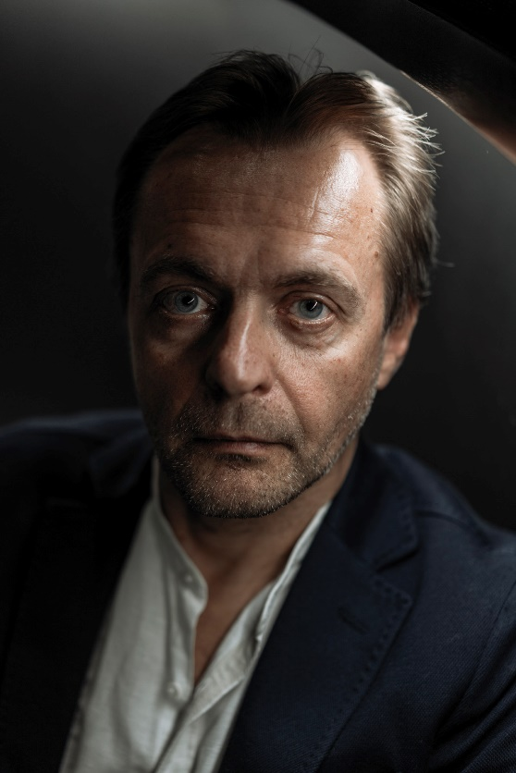
Vaidas Jauniškis is a lecturer at the Lithuanian Academy of Music and Theatre, performing arts critic and cultural analyst.
He writes on the topics of performativity, political theatre, and cultural policy.
From 2005 to 2017, he worked at the Menų Spaustuvė, and founded and moderated the performing arts website www.menufaktura.lt.
Member of the Lithuanian Council for Culture since 2021.
Presentation abstract
With increasing amounts of visual information in communication channels, the auditory component is diminishing in significance. Renowned theatre visionaries of the previous century, the masters of auteur theatre, also prioritised the visual aspects of the stage over language. Nowadays, as genres blend together, the traditional language of drama is being enriched with visual elements encompassing movement, contemporary dance and circus. However, in traditional drama, and often in post-dramatic theatre, words continue to be the driving force of action.
Today, young directors are actively challenging established aesthetics, seeking to bring the language of dramatic characters closer to everyday life. They grapple with the problem of effectively conveying ideas through language. Actors tend to neglect refining their vocal skills after graduation, and the use of microphones as a technical crutch further erodes the skills they have acquired. Emerging technologies and the aesthetics of daily life are undermining the craft of actors and the expression of stage language. Simultaneously, this shift deprives the audience of the joy of experiencing language, which remains a vital element of theatre.

