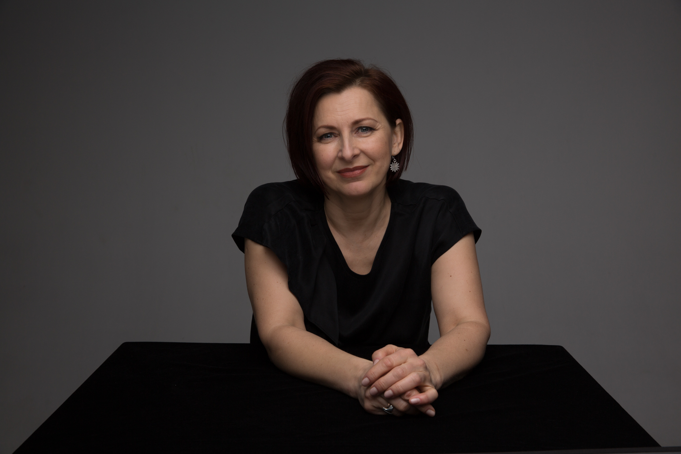

PhD Zane Daudzina is an actress, a consultant and trainer in voice and speech with a professional experience about 20 years.

Since 2000, actress and oratory educator Zane Daudziņa has lectured at the Latvian Academy of Culture, working with budding actors, directors and lately with cultural theory and management studies students. From 2005-2010, Zane gave stage oratory masterclasses to Polish students at drama schools in Cracow, Wroclaw and Warsaw. Her lecture courses include “Stage Oratory and Methodology”, “The Practical Skill of Speaking”, “Public Speaking” and “The Voice in Motion”.

Zane gained her Master’s degree in Philology of Latvian Language and Literature at the University of Latvia, and her Master’s degree in Performing Arts Voice Pedagogy at the Latvian Academy of Culture. She has supplemented her education in the program “University Teacher Pedagogical Perfection/ Innovations in the Higher Education System/ Education Work Management” (University of Latvia), at the course “Using Voice on Stage” (Maastricht Summer University, Amsterdam), “Voice as the Engine of the Body” (Utrecht Summer School, the Netherlands), “Action and Words” (Odin Theatre, Denmark) and others.

Currently, Zane is an actress, a voice consultant at Latvijas Radio (Latvia’s national public service radio broadcasting network) and an associate professor at the Latvian Academy of Culture.

Zane has integrated the knowledge she has acquired in practice in the voice and performing arts fields, in customer services, personnel management and communication training, as well as in team building projects, very successfully.

- There are two sides to actors’ speech – firstly, mastery of the set of skills facilitating the process, and, secondly, artistic execution of the all the elements included therein into the fact of theatre art, i.e. a production.
- In the theatre, stage speech as a separate system of signs most vividly expresses the other, that which belongs to the national cultural environment.
- Voice, which is the most nuanced manifestation of the actor’s instrument, reacts most sensitively to the tiniest internal or external changes in the actor’s body, it reflects the slightest physical shivers, the smallest twists of thought and the finest vibrations of the soul. Therefore, to a great extent these are all changes caused by objective external conditions, which affect the theatre –‒ creating audible changes in the actor’s speech.
- During the past quarter of a century, actors’ speech has undergone limitless changes in its intensity and quality, as well as in terms of quality and content. For the most part this is related to the active invasion of the theatre by modern technologies so evident during the 21st century, from which in all likelihood there will be no return.
- Under the influence of modern sound design technology, of all the actor’s vocational tools, actors’ speech has changed the most. There has been a change in the gradation of vocal power, vocal modulation capabilities and spectrum of vocal hues, and quite definitely the way of thinking, which nowadays the actor uses as an artist, in order to create a character in new, hitherto unprecedented, conditions generated by the digital environment.
- In the 21st century actors’ speech tools can be divided into two separate categories: psychophysical and technical. Psychophysical tools include: firstly – breathing, secondly – voice and, thirdly, articulation, as well as body plasticity: mimicry, gestures and general bodily manifestations, along with perception, memory and imagination. Technical speech tools include microphones, without which productions in large contemporary theatres would be practically unimaginable. The use of microphones and sound amplifiers has already reached hitherto unprecedented levels in the theatre.
- Since the actor’s voice must endure a large unusual workload on a daily basis, which includes all kinds of manifestations: loud talking, screaming, gasping, whimpering, laughing, crying, whispering, muttering, retching, moaning and howling, one must reiterate yet again that only by using a good vocal technique and sensibly managing the workload of the voice is it possible to ensure the sustainable endurance of the vocal cords and quality actors’ speech.
- Using the microphone as a voice amplification tool significantly reduces the actor’s ability to concentrate on the thought process of his character in a focused manner for a significantly length of time, because before coming on stage, the technical connection of the microphone and operating time of its batteries have to be checked several times. Instead of focusing on the process of stepping to into character and focusing on the action on stage, time and time again the actor is compelled to pay attention to the technical provisioning for the production. As a result, it is not the actor who controls events, but rather the director by choosing the intensity of the sound. In everyday work, this is the responsibility of the sound operator, who according to his taste, knowledge and competence regulates the volume and sharpness of the sound design.
- In regard to actors’ speech, during the 20th century the relationship between form and content was subjected to all kinds of experimental trials and continues to be controversial during the first two decades of the 21st century. Under the influence of postdramatic understanding of time and space, there has been a change in attitude in the theatre towards the text incorporated within the production. New Latvian theatre, which is extremely diverse, typically maintains a considerable distance from the written text; if it even exists in an adaptation, then it mainly serves as a conceptual source or quite simply as an impulse.
- In the 21st century Latvian theatre, the actor often becomes the author of the production’s text. This development within theatre art is so cardinal that transformations in actors’ speech are not only to be expected, but absolutely determined and inevitable.

