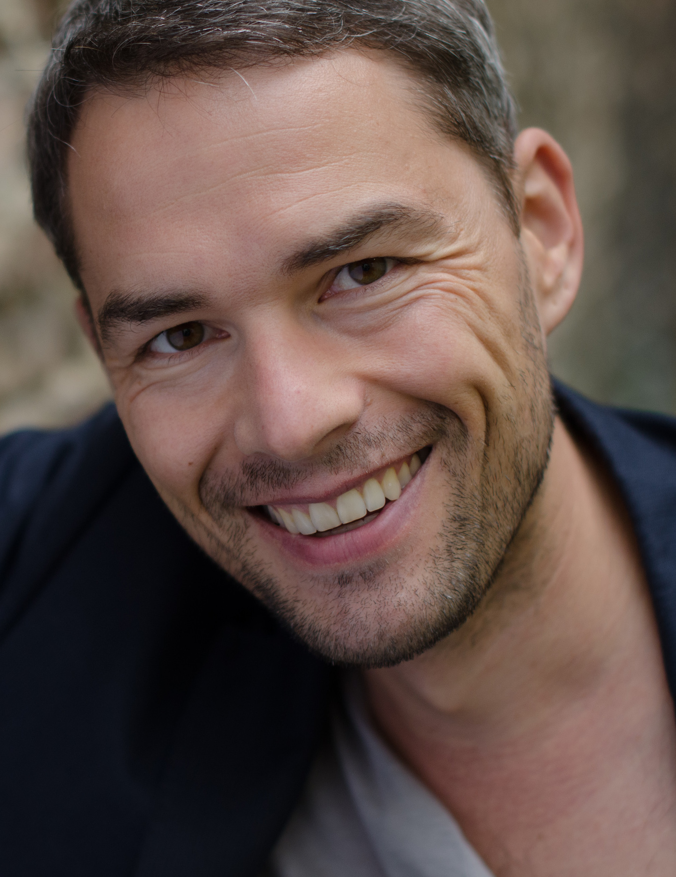

Markus Kunze
studied theater and media, German linguistics and literature, as well as sociology at the University of Erlangen/Nuremberg, and acting at the St. Petersburg State Theater Academy. He completed the master's program "Speech Communication and Rhetoric" in speech science and speech education at the University of Regensburg.
Markus Kunze teaches voice and speech at the Berlin University of the Arts. He also provides advanced trainings with a focus on presence, voice work and socio-communicative competences. In addition to his teaching and coaching activities, he works as a freelance actor, speaker and director.

presence of the body
&
presence of thought, word and articulation in speaking actions

The body is the starting point of the speaking action. Multisensory perception causes a physical readiness to act as a prerequisite for being able to shape the voice-speech and verbal dialogue with the audience.

The conscious presence of the body is accompanied by the activity of breath and attention and influences thought-speech processes.
Only on the basis of a body that is spontaneously ready to experience can voice and articulation convey the linguistic world of thought. Embodied by acting, it then enters into resonance with the audience.
Therefore, voice and speech of actors and performers should only be trained with the help of a physical, movement-rich speech training.

In the master class, exercises and principles are presented that train a free and balanced, present and acting body and, building on this, allow breath, voice and speech to be experienced as an acting moment.

