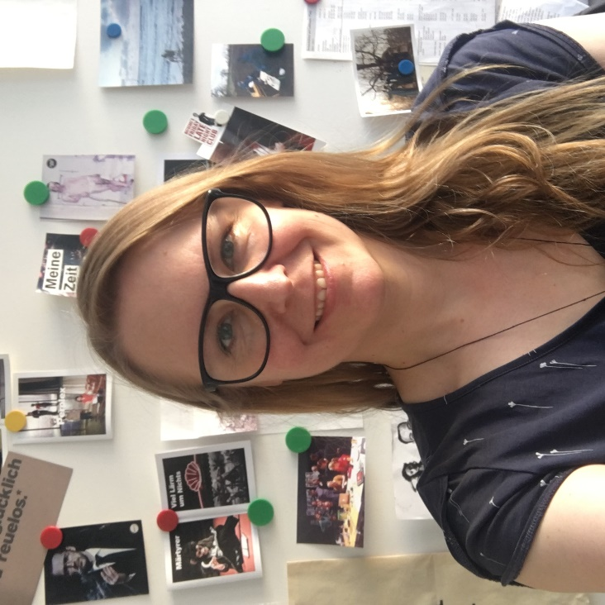
Maja Zade was raised in Germany and Sweden. She is head of dramaturgy at the Schaubühne Berlin, where she has worked since 1999. She studied English Literature at London University and at Queen’s University in Canada, and theatre production at the Royal Academy of Dramatic Art in London. From 1997 to 1999 she was Senior Reader at the Royal Court Theatre in London. She has taught at Malmö Theatre School and Edinburgh University since 2012, and is part of the jury for the James Tait Black Prize for Drama. Beside her work at the Schaubühne she has worked as a dramaturg for Michael Thalheimer productions at Dramaten, Stockholm. Various translations into German include work by Lars von Trier and Caryl Churchill and translations into English (from German and Swedish) by Marius von Mayenburg, Lars Noren and Falk Richter. In 2019 she started writing plays (status quo, abgrund, ödipus, reden über sex) that all premiered at the Schaubühne and have been translated into e.g. Norwegian, Swedish, Latvian, Polish, French and English.

How ideas about theatre influence how actors speak

It seems to me that how actors speak is closely linked to the theatrical landscape of the time, to what kind of plays are being written, and to what kind of theatre is being produced. You cannot separate how people speak on stage from the aesthetic of the production or from the artistic taste of the director or the company. In Germany in general, in Berlin and at the Schaubühne specifically, where I work as a dramaturg and as a playwright, there has been a movement towards a more "natural" way of speaking the lines. This development goes hand in hand with particular artistic but also political ideas. I want to talk about what those ideas are and why this development can also be seen as positive.

