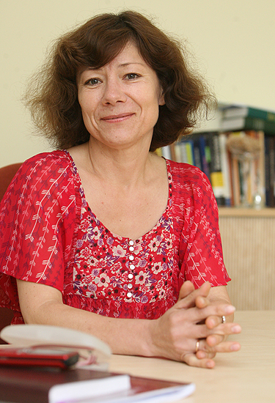
Irena Kruopienė is a Lithuanian linguist, Doctor of Humanities (2000), Director of LINGUA LITUANICA Institute of Language and Culture (Vilnius, Lithuania). A graduate of the Vilnius University (1984), until 2007, she taught Lithuanian philology at her alma mater. Since 2007, Irena Kruopienė has been an associate professor at the Department of Acting and Directing at the Lithuanian Academy of Music and Theatre (LMTA); from 2013 to 2017, she was a professor at Mykolas Romeris University (Vilnius, Lithuania). Irena Kruopienė’s research areas range from phonetics, phonology (morphology), pronunciation, and accentuation to language culture and language didactics. Dr. Kruopienė is a frequent guest at the Lithuanian radio and television where she participates at educational programmes dedicated to the issues of the Lithuanian language. In addition to this, Irena Kruopienė runs pronunciation and accentuation seminars for media professionals and teaches Lithuanian to foreigners.
Dr. Irena Kruopienė has published several books: A Brief Description of the Phonetics of the Lithuanian Language (Lt. Trumpas lietuvių kalbos fonetikos aprašas, 1996); Pronounce It: A Book of Correct Pronunciation (Lt. Ištark…: Taisyklingos tarties mokomoji knyga, 2004); Basic Lithuanian (with G. Kačiuškiene, 2007; Lt. Lietuvių kalbos pradmenys); Let's Meet: A Short Course of the Lithuanian Language for Beginners (Lt. Susipažinkime: Trumpas lietuvių kalbos kursas pradedantiesiems); and Let's Grow: A Short Course of the Lithuanian language for Advanced Learners (Lt. Tobulėkime: Trumpas lietuvių kalbos kursas mokantiesiems; both 2008); 10 Steps: A Short Course of the Lithuanian Language for Beginners (Lt. 10 žingsnių: Trumpas lietuvių kalbos kursas pradedantiems, 2009); Let's Talk: The Basic Course of the Lithuanian Language (Lt. Pasikalbėkime: Lietuvių kalbos pagrindų kursas written with a group of co-authors, 2017); and Step Across the Threshold: B1 Level Lithuanian Language Course (Lt. Perženk slenkstį: B1 lygio lietuvių kalbos kursas, 2018).
Dr. Irena Kruopienė participates in a wide range of scientific conferences and has published over 50 research papers and articles.

Correct Spoken Expression – Aspiration and Reality

Recently, there has been a heated discussion about the continuously worsening verbal expression of the young generation – distorted articulation, accentuation and intonation mistakes. Pronunciation and accentuation are a hard nut to crack. We may all make mistakes and actors are no exception – however, their mistakes are more conspicuous. Quite often, we expect to hear impeccable speech from the television, radio, or theatre; yet, unfortunately, what we are exposed to is far from a good example. Inaccuracies are in every area – the culture of the language, vocabulary, accentuation, but what primarily draws our attention is incorrect pronunciation. That is why I would like to focus on the peculiarities, patterns and trends of the verbal expression of professional and student actors and overview the most acute problems. These, by the way, are also recognised by the students themselves. If you ask students what they think of their pronunciation, what is good in their speech and what needs to be corrected, they usually name the pronunciation of the long and short vowels (among them, of course, ē and o). Indeed, this is so true, and is not the problem of actors only. Recently, there has been a noticeable trend or a speaking manner among young people to produce sounds with flabby or loose speech organs. When speaking like that, it is impossible to pronounce the long vowels. Moreover, whole syllables are no longer pronounced, especially in the word endings.
Having discussed these and other issues, the presentation emphasises the idea that we all together should search for attractive and efficient ways of developing spoken expression; so that our ambition – correct, flowing and natural language –becomes reality.

