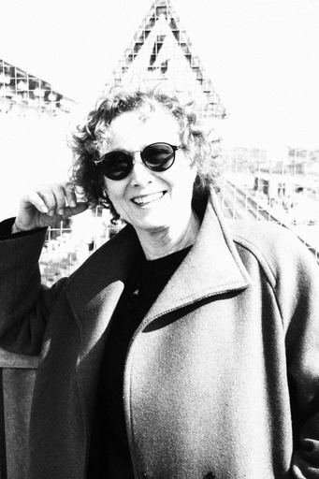

Nelė Savičenko is a theatre and film actress, a stage language teacher, and a professor. Her teaching and acting career has continued for over 30 years.

The Importance of Stage Speech for the Actor's Creative Work

In this presentation, I am raising questions the answers to which are more intuitive than known. Will the renaissance of the language come to the theatre and will it be needed? We know what kind of the theatre language there was and what its objectives were; we know its theoretical foundation that was shaped more than a hundred years ago. But it is obvious how everything has changed: society, topics, ways of expression. By means of new technologies, we are dissolving the boundaries of disciplines and creating new norms of ethics and aesthetics.
Today we are asking: Is stage speech becoming more mediocre or is it acquiring a new value? Will language find its place in the new theatre?
For many years, I have been teaching stage language to actors; now I’m teaching their seventh generation, so I want to share my insights into the transformation of the stage language and how it will determine the future of the theatre.

