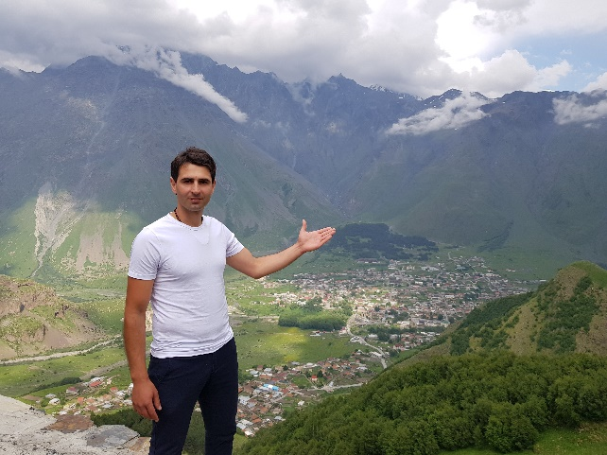
Irakli Dudauri graduated from Tbilisi State University of Economic Relations (2010) and has a Master of Economics.
Since 2017, has been studying Lithuanian at the Lithuanian Language and Culture Centre of Georgian Technical University.
Has participated in international conferences in Lithuania, Georgia, Estonia and the Czech Republic. The winner of the European Union project Žingsniai 2020, carried out in Lithuania.
Since 2018, Student President of the Lithuanian Language and Culture Centre. Teaches Lithuanian to beginner students at the Lithuanian Language and Culture Center of Georgia Technical University.

How to Pronounce the Lithuanian Word so that Others Understand You
Georgian Technical University, Lithuanian Language and Culture Centre
This is a presentation on the teaching methodology developed by distinguished Lithuanian linguist Prof. Dr. Vidas Kavaliauskas who created a new culture in Georgia. I was one of Professor’s students and later became his assistant, so I will share with you some key aspects of his methodology.
In its core, there is a rating system. Students are awarded scores for all activities – lectures, homework assignments, tests, exams. Participation in or attendance of cultural events and international conferences is also awarded a score. It all greatly increases a healthy competition and unites students.
It is important that during the lectures, students could learn about Lithuania, its culture, history, future prospects – this is relevant for those who have already learned the Lithuanian language. Students also learn Lithuanian songs and poems, get acquainted with the works by prominent Lithuanian writers related to Georgia. All this enriches the vocabulary of the students' Lithuanian language. From my own experience, I can confirm that the Lithuanian language is the key to success – in half a year I reached the B2 level.
This happened to my exceptional love for Lithuania and the Lithuanian language. I did my internship with Professor’s help, and this was how I was able to improve my Lithuanian– I translated lectures from Lithuanian to Georgian, helped to score homework and exam assignments, participated in international conferences in the Lithuanian language. Within the programme of the European Union and Lithuanian Support Foundation, I attended Lithuanian language courses at Vilnius University, did an internship at the Georgian Embassy in Lithuania and the Prime Minister's Office. The Lithuanian language studies provided me with an opportunity to participate in educational programmes in Lithuania. This helped to learn more about this country, its regions and people. Together with other students of the Centre, I had an opportunity to meet Lithuania’s people and introduce them to the culture of Georgia.
Thanks to the Lithuanian Language and Culture Centre in Georgia, I was able to learn about the Lithuanian culture, speak with local people, and develop in the professional field. Prof. Kavaliauskas' teaching methodology, which is not limited to the study of the Lithuanian language, has broadened my worldview. All students of the Centre have such opportunities. This opens the way to success, helps to learn more about the culture, language, people of another country, and, most importantly, gain invaluable knowledge.

