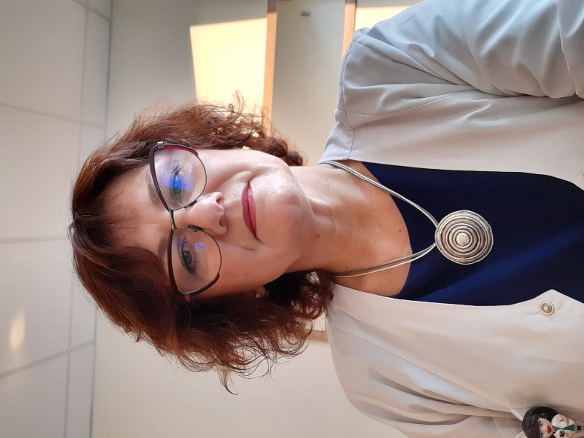

Sigita Kudakauskienė

Vilnius University Hospital Santaros Klinikos Centre of Rehabilitation, Physical and Sports Medicine
Clinical speech therapist

I am persistently developing my professional qualification by sharing my experience at seminars, conferences, and international congresses.
Since 2018 - a member of the Lithuanian Speech Therapists Association, an active participant of its events.
Since 2016 – a member of the Huntington Disease Association: I participate in the training sessions organised by the Association for patients, their families, and doctors, and I also give presentations.
At the conferences for Lithuanian neurologists, I have given presentations on the treatment of speech and speaking disorders, dysarthria, dysphagia, dysphonia; and I also work with patients with such disorders.
At the 2018 International Congress of Rehabilitators, together with rehabilitator I. Michailovienė, we gave a presentation on the application of electrostimulation using the Voca STIM apparatus for patients with Huntington disease.
In 2017, I taught a course on aphasia and swallowing disorders to postgraduate students at the Šiauliai University (Lithuania). I give lectures at Vilnius University Hospital Santaros Clinics to students at the Faculty of Medicine about the relevance of a clinical speech therapist’s role for rehabilitation.

Functions and competencies of a speech therapist. The most common voice disorders and their treatment. Speech therapy support for adults

- Functions and competencies of a speech therapist.

- The most common voice disorders, their treatment and prevention. An overview of the most common voice disorders, when to apply for support, how to treat and prevent these disorders.

- Neurological disorders of speaking and speech. Support for people who have suffered neurological or traumatic brain damage.

- Disfluent speech and speech impediments related to mispronunciation in adults. Speech pace and rhythm disorders, stuttering, too rapid and too slow speech. The most common sound pronunciation disorders. Diction.

Speech therapy support at the Vilnius University Hospital Santaros Klinikos Centre of Rehabilitation, Physical and Sports Medicine

